Angular

* **What is the Angular ?**

Ans) Angular is a **Javascript** Framework which allows you to create reactive **Single-Page-Application** (SPAs)

Its always look like mobile application ,JavaScript change the DOM

* **Angular 7 vs Angular 6 vs Angular 2 vs Angular 1**

|  |  |
| --- | --- |
| Angular 7 | Angular 1 |
| Angular 6 |
| Angular 2 |

Run time, its provide highly interactive user experience without reloading page

Angular 2 is completely rewriting its released at 2016,

|  |  |
| --- | --- |
| Just “Anghular” | Angular JS |

* **Typescript**

Compiled to

More feature than vanilla JS

{EG:Types,Classes,Interfaces

()

JavaScript

TypeScript

* **Integration bootstrap** 
  1. **npm install --save bootstrap**
  2. **angular.json**
* "architect": {
* "build": {
* ],
* "styles": [
* "node_modules/bootstrap/dist/css/bootstrap.min.css",
* "src/styles.css"
* ],
* **First executed main.ts**

import { enableProdMode } from '@angular/core';

import { platformBrowserDynamic } from '@angular/platform-browser-dynamic';

import { AppModule } from './app/app.module';

import { environment } from './environments/environment';

if (environment.production) {

enableProdMode();

}

platformBrowserDynamic().bootstrapModule(AppModule)

.catch(err => console.error(err));

import { BrowserModule } from '@angular/platform-browser';

import { NgModule } from '@angular/core';

import { AppRoutingModule } from './app-routing.module';

import { AppComponent } from './app.component';

@NgModule({

declarations: [

AppComponent

],

imports: [

BrowserModule,

AppRoutingModule

],

providers: [],

bootstrap: [AppComponent]

})

export class AppModule { }

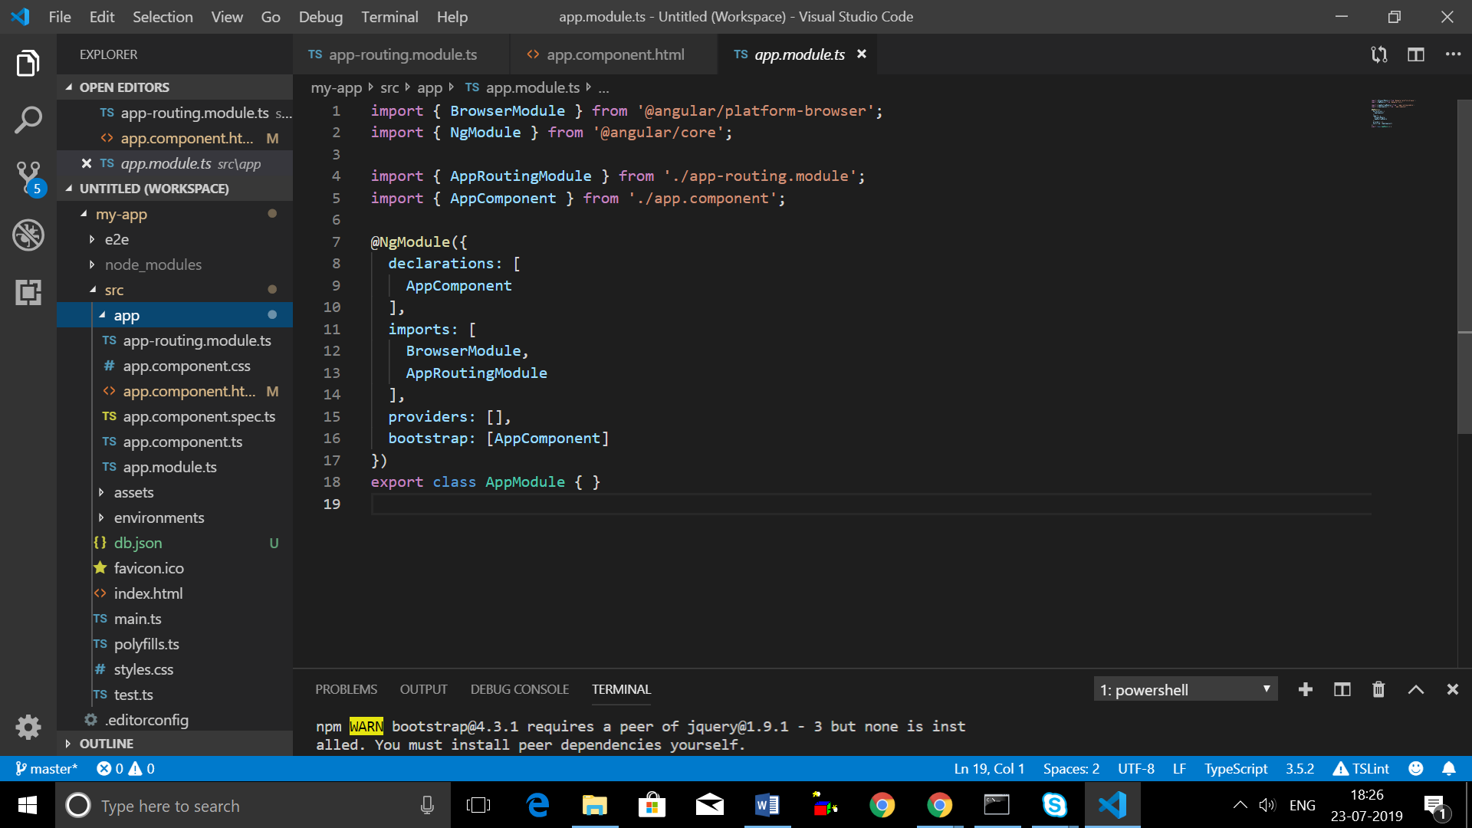

**Component L-15**

* Component is key feature in angular you can build hole application my composing by couple of components

Users

Home

Htttps://angular-deriver.com

* Each component have they own business logic and own styling
* you can user reusable component, you may use component more then one
* component is just like a TypeScript class
* **Decorator(@Component(){})** is nothing but enhance the component
* **Selector** should be unique

Server.component.ts

import { Component } from '@angular/core';

@Component({

selector: 'app-server',

templateUrl: './server.component.html'

})

export class ServerComponent {

}

Server.component.html

<p>Testing </p>

**L-16-AppModules**

**Note: im saying ‘app’ here because we only have one module ,hence representing our complete app!**

* Which feature my app does have and use
* At the end the point your hole application start so which component which basically recognize in the index html file

L-17

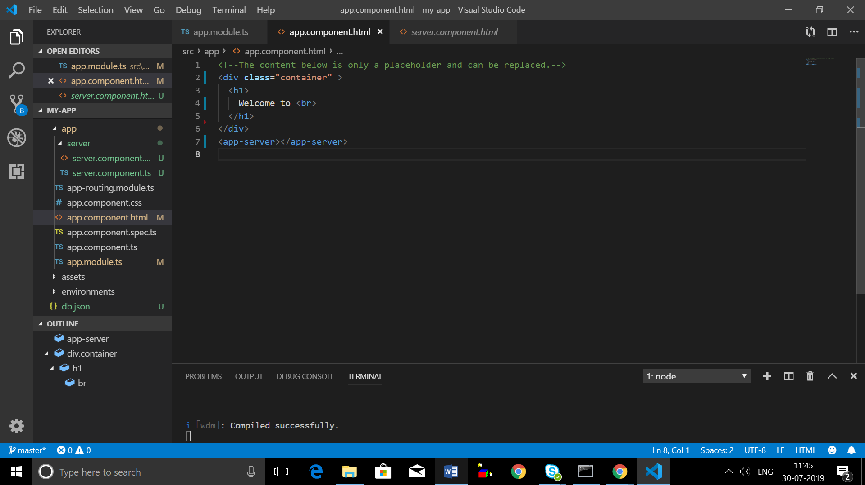

After adding app-server tag in app.component.html will get output

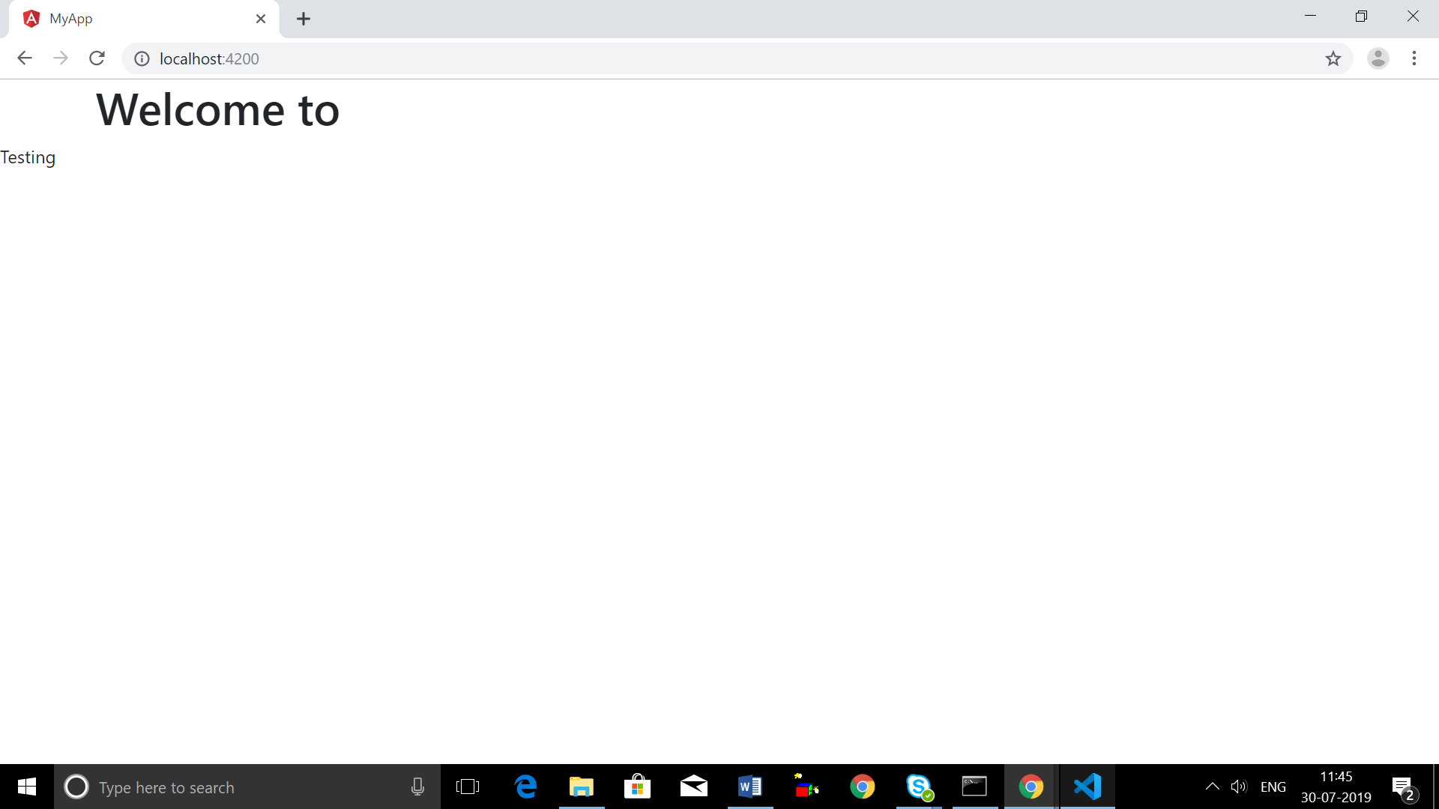

**L-18====Create Component with CLI Nesting Component**

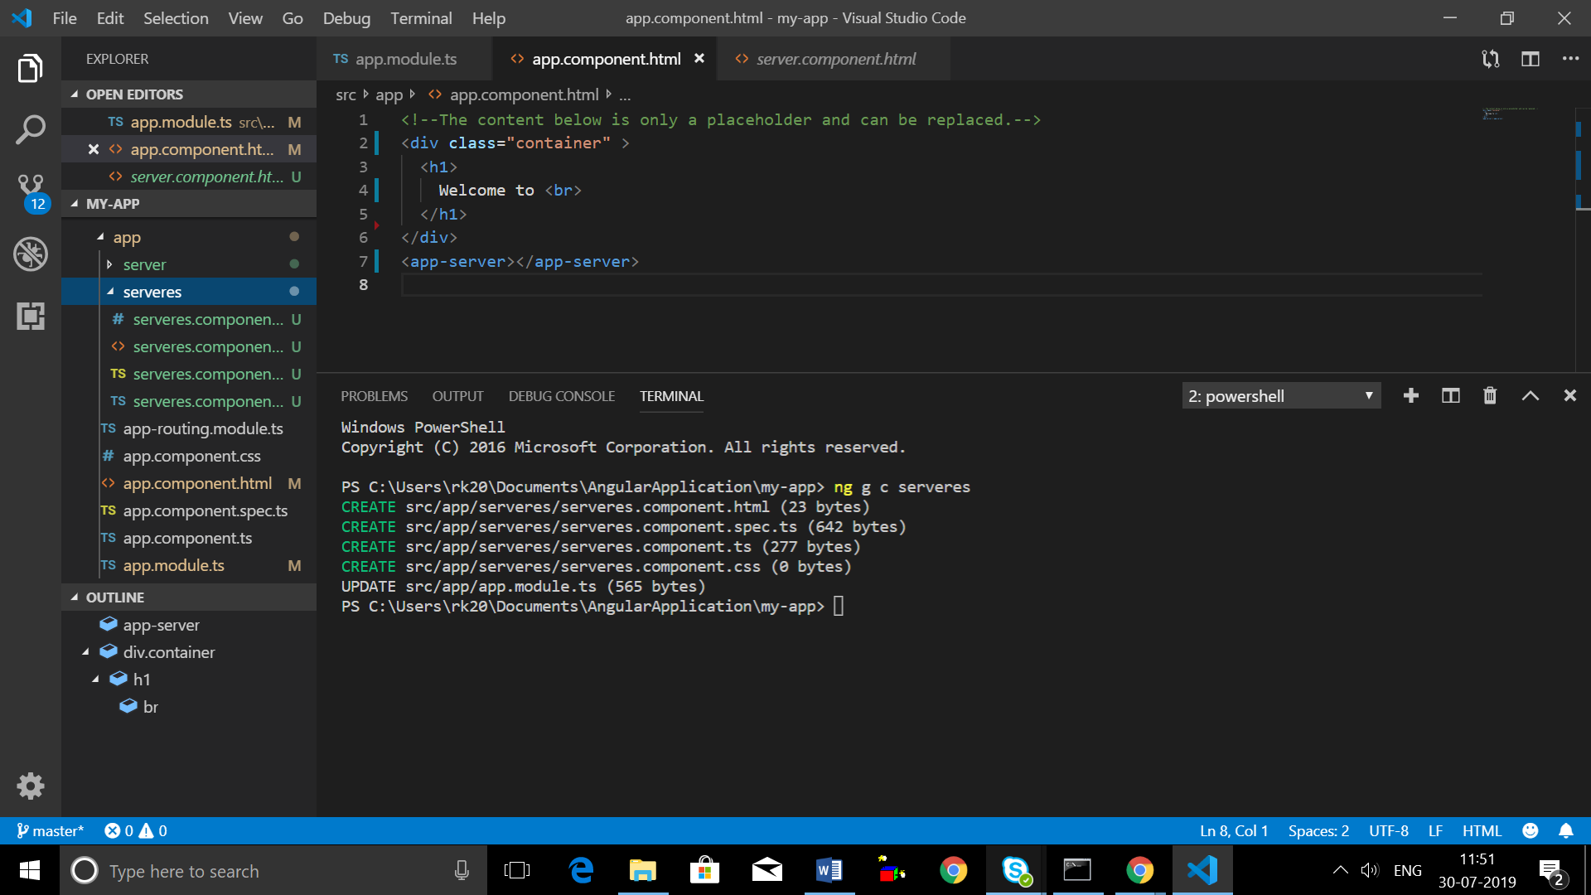

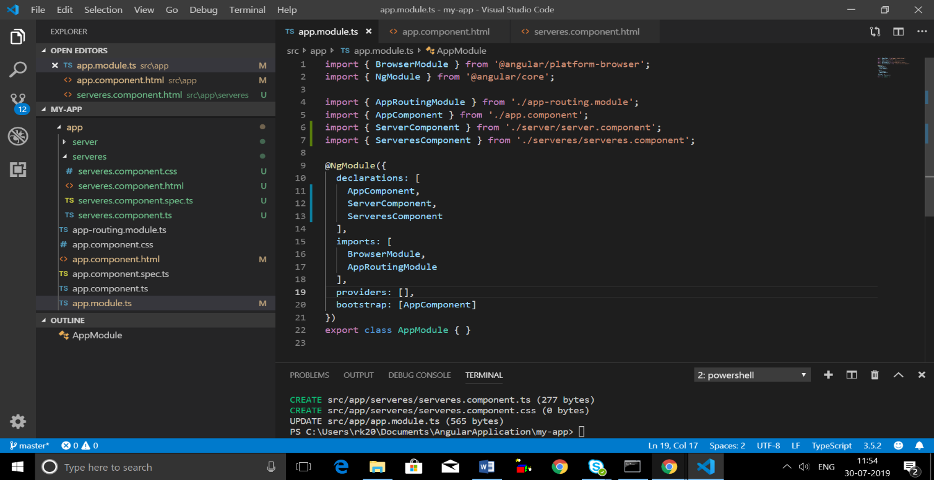By using cli component should automatically import in APP_MODULE